N = 4

1. NaCl

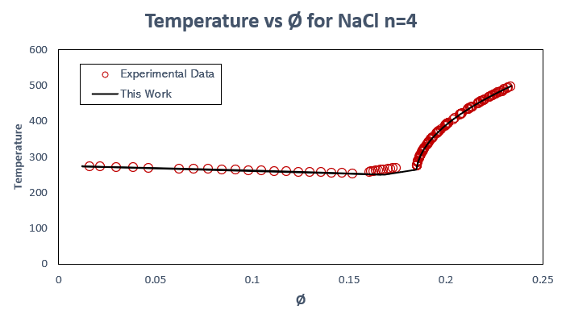

1. Li2SO4

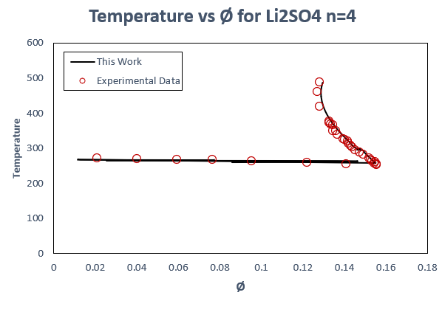

1. CaCl2

1. LiCl

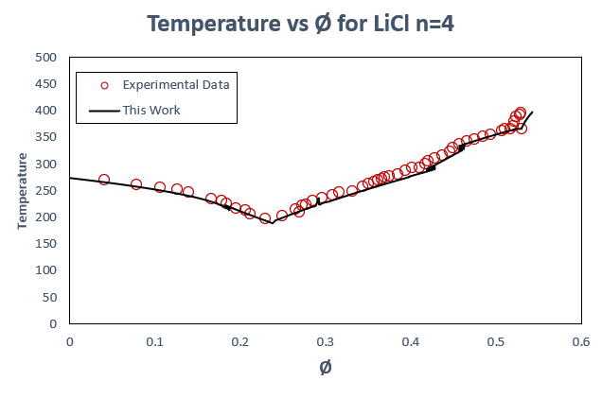

1. MgSO4

